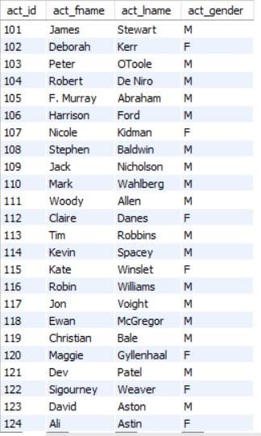
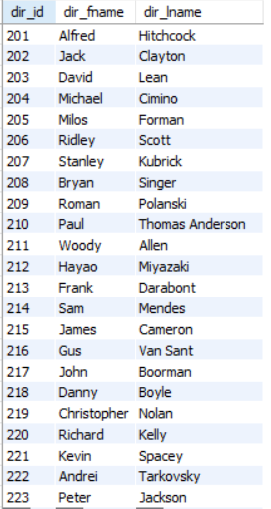
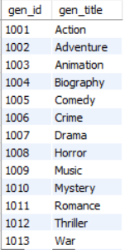
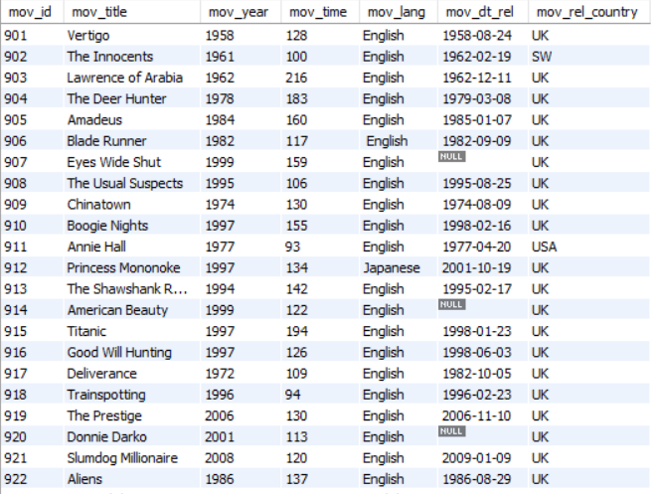
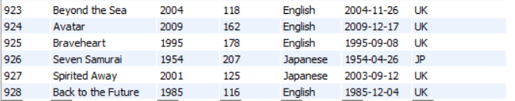
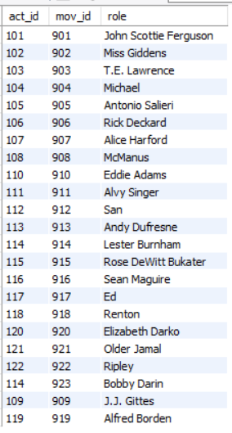
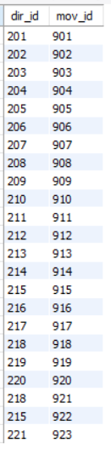
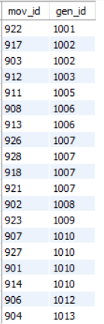
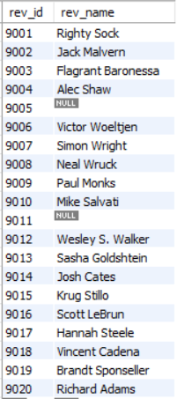
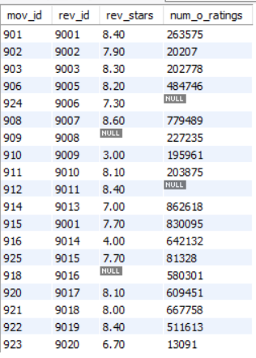
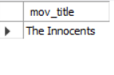
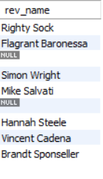
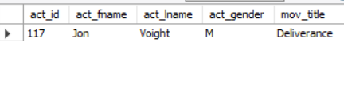
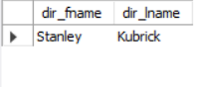
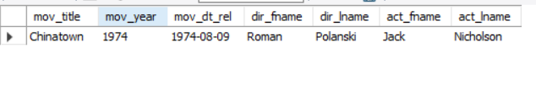
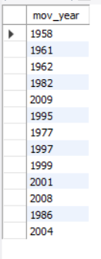
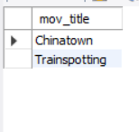
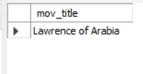
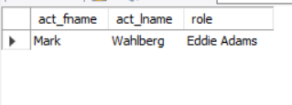

Sarath Sankar
Employee ID : 211484

1.Create Database project_movie_data and deploy table data according to ER diagram.

Create database Project_movie_data;
use project_movie_data;
2. Create 9 tables which are presented in ER model and load the data with their foreign key and primary key values.

Creating Databases and Tables
- create table Actor( act_id int, act_fname char(15),act_lname char(15),act_gender char(5), primary key (act_id));
create table Director( dir_id int, dir_fname char(15),dir_lname char(15),primary key (dir_id));
select * from movies;
create table Genres( gen_id int, gen_title char(15), primary key (gen_id));
create table Movie_Cast( act_id int, mov_id int,act_role char(20));
create table Movies( mov_id int, mov_title char(25),mov_year int(5), mov_time int, mov_lang char(20),mov_dt_rel date,mov_rel_country char(15), primary key (mov_id));
create table movie_direction (dir_id int(4) , mov_id int(4));
create table movie_genres (
mov_id int(5) NOT NULL,
gen_id int(5) NOT NULL
);
create table rating (
mov_id int(5) NOT NULL,
rev_id int(5) NOT NULL,
rev_stars decimal(4,0) NOT NULL,
num_o_ratings int(10) NOT NULL,
primary key (rev_id));
create table Reviewer( rev_id int, rev_name char(20));
drop table Movies;

- Inserting values into the tables
- insert into actor (act_id, act_fname, act_lname, act_gender) VALUES
(101, ' James ', ' Stewart ', ' M'),
(102, ' Deborah ', ' Kerr ', ' F'),
(103, ' Peter ', ' OToole ', ' M'),
(104, ' Robert ', ' De Niro ', ' M'),
(105, ' F. Murray', ' Abraham ', ' M'),
(106, ' Harrison ', ' Ford ', ' M'),
(107, ' Nicole ', ' Kidman ', ' F'),
(108, ' Stephen ', ' Baldwin ', ' M'),
(109, ' Jack ', ' Nicholson', ' M'),
(110, ' Mark ', ' Wahlberg ', ' M'),
(111, ' Woody ', ' Allen ', ' M'),
(112, ' Claire ', ' Danes ', ' F'),
(113, ' Tim ', ' Robbins ', ' M'),
(114, ' Kevin ', ' Spacey ', ' M'),
(115, ' Kate ', ' Winslet ', ' F'),
(116, ' Robin ', ' Williams ', ' M'),
(117, ' Jon ', ' Voight ', ' M'),
(118, ' Ewan ', ' McGregor ', ' M'),
(119, ' Christian', ' Bale ', ' M'),
(120, ' Maggie ', ' Gyllenhaa', ' F'),
(121, ' Dev ', ' Patel ', ' M'),
(122, ' Sigourney', ' Weaver ', ' F'),
(123, ' David ', ' Aston ', ' M'),
(124, ' Ali ', ' Astin ', ' F');
insert into Director (dir_id, dir_fname, dir_lname) values
(201, ' Alfred ', ' Hitchcock'),
(202, ' Jack ', ' Clayton'),
(203, ' David ', ' Lean'),
(204, ' Michael ', ' Cimino'),
(205, ' Milos ', ' Forman'),
(206, ' Ridley ', ' Scott'),
(207, ' Stanley ', ' Kubrick'),
(208, ' Bryan ', ' Singer'),
(209, ' Roman ', ' Polanski'),
(210, ' Paul ', ' Thomas An'),
(211, ' Woody ', ' Allen'),
(212, ' Hayao ', ' Miyazaki'),
(213, ' Frank ', ' Darabont'),
(214, ' Sam ', ' Mendes'),
(215, ' James ', ' Cameron'),
(216, ' Gus ', ' Van Sant'),
(217, ' John ', ' Boorman'),
(218, ' Danny ', ' Boyle'),
(219, ' Christoph', ' Nolan'),
(220, ' Richard ', ' Kelly'),
(221, ' Kevin ', ' Spacey'),
(222, ' Andrei ', ' Tarkovsky'),
(223, ' Peter ', ' Jackson');
INSERT INTO Genres (gen_id, gen_title) VALUES
(1001, ' Action'),
(1002, ' Adventure'),
(1003, ' Animation'),
(1004, ' Biography'),
(1005, ' Comedy'),
(1006, ' Crime'),
(1007, ' Drama'),
(1008, ' Horror'),
(1009, ' Music'),
(1010, ' Mystery'),
(1011, ' Romance'),
(1012, ' Thriller'),
(1013, ' War');
insert into movie_cast (act_id, mov_id, act_role) VALUES
(101, 901, ' John Scottie Fergus'),
(102, 902, ' Miss Giddens'),
(103, 903, ' T.E. Lawrence'),
(104, 904, ' Michael'),
(105, 905, ' Antonio Salieri'),
(106, 906, ' Rick Deckard'),
(107, 907, ' Alice Harford'),
(108, 908, ' McManus'),
(110, 910, ' Eddie Adams'),
(111, 911, ' Alvy Singer'),
(112, 912, ' San'),
(113, 913, ' Andy Dufresne'),
(114, 914, ' Lester Burnham'),
(115, 915, ' Rose DeWitt Bukater'),
(116, 916, ' Sean Maguire'),
(117, 917, ' Ed'),
(118, 918, ' Renton'),
(120, 920, ' Elizabeth Darko'),
(121, 921, ' Older Jamal'),
(122, 922, ' Ripley'),
(114, 923, ' Bobby Darin'),
(109, 909, ' J.J. Gittes'),
(119, 919, ' Alfred Borden');
INSERT INTO Movies (mov_id, mov_title, mov_year, mov_time, mov_lang, mov_dt_rel, mov_rel_country) VALUES
(901, ' Vertigo ', 1958, 128, ' English ', '1958-08-24', ' UK'),
(902, ' The Innocents ', 1961, 100, ' English ', '1962-02-19', ' SW'),
(903, ' Lawrence of Arabia ', 1962, 216, ' English ', '1962-12-11', ' UK'),
(904, ' The Deer Hunter ', 1978, 183, ' English ', '1979-03-08', ' UK'),
(905, ' Amadeus ', 1984, 160, ' English ', '1985-01-07', ' UK'),
(906, ' Blade Runner ', 1982, 117, ' English ', '1982-09-09', ' UK'),
(907, ' Eyes Wide Shut ', 1999, 159, ' English ', '0000-00-00', ' UK'),
(908, ' The Usual Suspects ', 1995, 106, ' English ', '1995-08-25', ' UK'),
(909, ' Chinatown ', 1974, 130, ' English ', '1974-08-09', ' UK'),
(910, ' Boogie Nights ', 1997, 155, ' English ', '1998-02-16', ' UK'),
(911, ' Annie Hall ', 1977, 93, ' English ', '1977-04-20', ' USA'),
(912, ' Princess Mononoke ', 1997, 134, ' Japanese ', '2001-10-19', ' UK'),
(913, ' The Shawshank Redem', 1994, 142, ' English ', '1995-02-17', ' UK'),
(914, ' American Beauty ', 1999, 122, ' English ', '0000-00-00', ' UK'),
(915, ' Titanic ', 1997, 194, ' English ', '1998-01-23', ' UK'),
(916, ' Good Will Hunting ', 1997, 126, ' English ', '1998-06-03', ' UK'),
(917, ' Deliverance ', 1972, 109, ' English ', '1982-10-05', ' UK'),
(918, ' Trainspotting ', 1996, 94, ' English ', '1996-02-23', ' UK'),
(919, ' The Prestige ', 2006, 130, ' English ', '2006-11-10', ' UK'),
(920, ' Donnie Darko ', 2001, 113, ' English ', '0000-00-00', ' UK'),
(921, ' Slumdog Millionaire', 2008, 120, ' English ', '2009-01-09', ' UK'),
(922, ' Aliens ', 1986, 137, ' English ', '1986-08-29', ' UK'),
(923, ' Beyond the Sea ', 2004, 118, ' English ', '2004-11-26', ' UK'),
(924, ' Avatar ', 2009, 162, ' English ', '2009-12-17', ' UK'),
(925, ' Braveheart ', 1995, 178, ' English ', '1995-09-08', ' UK'),
(926, ' Seven Samurai ', 1954, 207, ' Japanese ', '1954-04-26', ' JP'),
(927, ' Spirited Away ', 2001, 125, ' Japanese ', '2003-09-12', ' UK'),
(928, ' Back to the Future ', 1985, 116, ' English ', '1985-12-04', ' UK');
INSERT INTO movie_direction (dir_id, mov_id) VALUES
(201, 901),
(202, 902),
(203, 903),
(204, 904),
(205, 905),
(206, 906),
(207, 907),
(208, 908),
(209, 909),
(210, 910),
(211, 911),
(212, 912),
(213, 913),
(214, 914),
(215, 915),
(216, 916),
(217, 917),
(218, 918),
(219, 919),
(220, 920),
(218, 921),
(215, 922),
(221, 923);
INSERT INTO movie_genres (mov_id, gen_id) VALUES
(922, 1001),
(917, 1002),
(903, 1002),
(912, 1003),
(911, 1005),
(908, 1006),
(913, 1006),
(926, 1007),
(928, 1007),
(918, 1007),
(921, 1007),
(902, 1008),
(923, 1009),
(907, 1010),
(927, 1010),
(901, 1010),
(914, 1010),
(906, 1012),
(904, 1013);
INSERT INTO rating (mov_id, rev_id, rev_stars, num_o_ratings) VALUES
(901, 9001, '8', 263575),
(902, 9002, '8', 20207),
(903, 9003, '8', 202778),
(906, 9005, '8', 484746),
(924, 9006, '7', 0),
(908, 9007, '9', 779489),
(909, 9008, '0', 227235),
(910, 9009, '3', 195961),
(911, 9010, '8', 203875),
(912, 9011, '8', 0),
(914, 9013, '8', 862618),
(916, 9014, '4', 642132),
(925, 9015, '8', 81328),
(918, 9016, '0', 580301),
(920, 9017, '8', 609451),
(921, 9018, '8', 667758),
(922, 9019, '8', 511613),
(923, 9020, '7', 13091);
insert into Reviewer( rev_id , rev_name) values
(9001,'Righty Sock'),
(9002,'Jackmavlen'),
(9003,'Flagrant Baronessa'),
(9004,'Alec Shaw'),
(9005,'Alen'),
(9006,'Victor Woeltjen'),
(9007,'Simon Wright'),
(9008,'Neal Wruck'),
(9009,'Paul Monks'),
(9010,'Mike salvati'),
(9011,'Sam'),
(9012,'Wesley S Walker'),
(9013,'Sasha Goldshtein'),
(9014,'Josh cates'),
(9015,'Krug Stillo'),
(9016,'scott lebrun'),
(9017,'Hannah Stelle'),
(9018,'Vinccent Cadena'),
(9019,'Bradt Sponseller'),
(2020,'Richard Adams');

Actor

Director

Genres

Movies

Movie cast

Movie Direction

Movie Genres

Reviewer

Rating

3. Write a query in SQL to list the Horror movies?
SELECT mov_title
FROM movie WHERE mov_id=(SELECT mov_id FROM movie_genres
WHERE gen_id in (SELECT gen_id FROM genres WHERE gen_title='Horror'));

4. Write a query in SQL to find the name of all reviewers who have rated 8 or more stars?

SELECT reviewer.rev_name
FROM reviewer, rating
WHERE rating.rev_id = reviewer.rev_id
AND rating.rev_stars>=8
AND reviewer.rev_name IS NOT NULL;

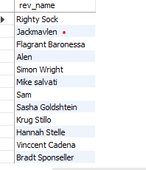

5. Write a query in SQL to list all the information of the actors who played a role in the movie ‘Deliverance’
SELECT *
FROM actor
WHERE act_id IN(
SELECT act_id
FROM movie_cast
WHERE mov_id IN (
SELECT mov_id
FROM movies
WHERE mov_title='Deliverance'
));

6. Write a query in SQL to find the name of the director (first and last names) who directed a movie that casted a role for ‘Eyes Wide Shut’. (using subquery)

SELECT dir_fname, dir_lname
FROM director
WHERE dir_id in (
SELECT dir_id
FROM movie_direction
WHERE mov_id in(
SELECT mov_id
FROM movie_cast WHERE act_role = ANY (
SELECT act_role
FROM movie_cast
WHERE mov_id IN (
SELECT mov_id
FROM movies
WHERE mov_title='Eyes Wide Shut'))));

7. Write a query in SQL to find the movie title, year, date of release, director and actor for those movies which reviewer is ‘Neal Wruck’
SELECT mov_title, mov_year, mov_dt_rel, dir_fname, dir_lname, act_fname, act_lname
FROM movies a, movie_direction b, director c, rating d, reviewer e, actor f, movie_cast g
WHERE a.mov_id=b.mov_id AND b.dir_id=c.dir_id AND a.mov_id=d.mov_id AND d.rev_id=e.rev_id AND a.mov_id=g.mov_id AND g.act_id=f.act_id AND e.rev_name ="Neal Wruck";

